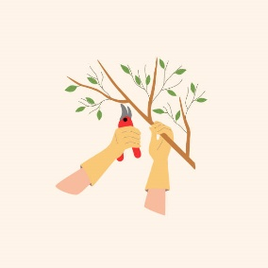
Full Bloom Nursery
Pruning Shrubs & Trees Workshop
with Extension Agent Garrett Hibbs

Fall Container Gardening with Cindy
Pruning is one of the most important cultural practices for maintaining woody plants, including ornamental trees, shrubs and fruits. It involves both art and science: art in making the pruning cuts properly, and science in knowing how and when to prune for maximum benefits. There are numerous reasons for pruning. Sometimes you want to train or direct the growth of plants into a particular form or a specified space, like a formal hedge. Or you may want to prune mature plants to control their size and shape, as in the case of fruit trees that are pruned to aid picking or hedge plants pruned at a particular height.
For fruiting plants, pruning plays an important role in improving overall fruit quality, primarily by increasing light penetration into the tree. Unfortunately, many people approach pruning with a great deal of apprehension. Others view pruning as a chore and give little forethought to technique as they hastily do the job. Proper pruning requires a basic understanding of how plants respond to various pruning cuts.
Generally, the more severe the pruning, the greater the resulting regrowth. In essence, the plant is regrowing in an attempt to restore a balance between the top and the root system. Pruning generally stimulates regrowth near the cut. Vigorous shoot growth will usually occur within 6 to 8 inches of the pruning cut. There are two basic types of pruning cuts, heading and thinning. Each results in a different growth response and has specific uses. Heading removes the top portion of shoots or limbs. Heading stimulates regrowth near the cut. It also is the most invigorating type of pruning cut, resulting in thick compact growth and a loss of natural form, as in the case of a formally pruned hedge. Sometimes ornamental shrubs along a foundation overgrow their planting space and are rejuvenated by heading to within 12 inches of ground level. Many broadleaf shrubs such as holly, ligustrum, abelia and crape myrtle tolerate this type of pruning. Thinning, on the other hand, removes an entire shoot or limb to its point of origin from the main limb or trunk. Thinning is generally the least invigorating type of pruning cut and provides a more natural growth form of plants.
Time of pruning varies with plant species. Woody ornamentals are pruned according to their date of flowering. For example, spring-flowering plants, such as dogwood, azalea or forsythia, normally are pruned after they bloom. Pruning spring-flowering shrubs during the dormant season will remove flower buds formed the previous fall. Summer-flowering plants generally are pruned during the dormant winter season. If plants are not grown for their flowers, the best time for pruning is during the dormant winter season before new growth begins in the spring. Avoid heavy pruning during the late summer and fall because regrowth may occur and make the plants more susceptible to cold injury. The location of pruning cuts on limbs is very important:
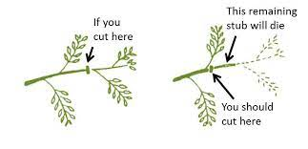

Spring blooming shrubs already have dormant flower buds along their stems and pruning before they bloom will remove the flowers. Spring blooming shrubs can be cut back hard in winter to reduce size, but you will sacrifice flowers for the season.

Popular shrubs that should be pruned AFTER they flower:
Azalea
Camellia
Forsythia
Hydrangea (blue mophead types)
Lorapetalum
Quince
Rhododendron
Viburnum
Weigela
Pruning trees
For best tree health, remove dead or damaged branches and branches that are rubbing against others. When removing an entire limb, avoid cutting too close to the trunk. Most limbs form a natural collar at the fork. Cut outside the edge of this collar. Don’t leave long stubs that can rot or slow healing, but don’t make flush cuts that remove the branch collar, the slight swelling where the branch meets the stem.

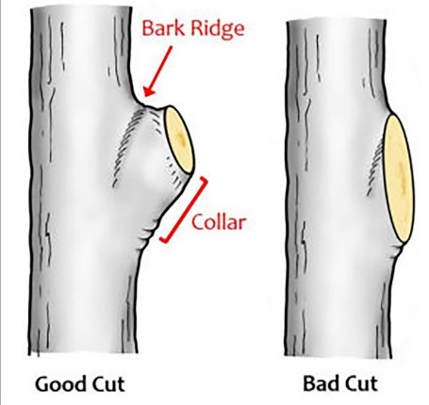

Many ornamental trees don’t need pruning if they have been placed in the proper location for their mature growth. Fruiting trees are pruned strategically depending on the species- see UGA’s publications on pruning fruiting trees.

